The Original Congregational Church
United Church of Christ
Sunday, February 27th, 2022 10am
Transfiguration Sunday

Order of Worship

PRELUDE “God Moves in a Mysterious Way, His Wonders to Perform”
from the Scottish Psalter of 1623
GREETING
Leader: The grace of our Lord Jesus Christ and the love of God and the fellowship of the Holy Spirit be with you all.
People: And also with you.

LIFE OF THE CHURCH
Notices for the program, ministries and people of the church are shared.

CALL TO WORSHIP
Leader: The morning skies shine forth divine light and flies.
People: Let all the earth around ring with joyous sound!
Leader: Let air, and sea and sky reply, on God’s love we rely!
People: To hear, in worship, the grace of God comes near!

*OPENING HYMN No. 111 When Morning Gilds the Skies

GATHERING PRAYER
Leader: God of morning light and sunset night, we pray that you shine down on us. Save us from our wandering ways. Lead us on to depart from places of burden and bitter regret. Move us to gain mountain perspectives and across the broad and open valleys. Let us catch a glimpse of your glory and to capture that in the soul, that we may share that forward with all, we pray. Amen.

THE LORD’S PRAYER all versions are welcomed in the Spirit
Our Father, who art in heaven, hallowed be thy name. Thy kingdom come. Thy will be done on earth as it is in heaven. Give us this day our daily bread. And forgive us our debts, as we forgive our debtors. And lead us not into temptation, but deliver us from evil. For thine is the kingdom, and the power, and the glory, forever and ever. Amen.

*All who are able please stand
( 1 )

RESPONSIVE READING from Psalm 80
Leader: Restore us, O God!
People: Let your face shine that we may be saved!
Leader: You brought a vine out of Egypt.
People: You cleared the ground and planted it.
Leader: It sent out its branches to the sea.
People: Its roots reached the river.
Leader: Why have the walls been broken down?
People: Why have the fields been ravaged?
Leader: Turn again, O God of Hosts!
People: Look down from heaven and see.
Leader: Restore us, O God!
People: Let your face shine, that we may be saved.

*ACT OF PRAISE No. 36
Glory be to the Father, and to the Son, and to the Holy Ghost; as it was in the beginning, is now, and ever shall be, world without end. Amen. Amen.

SCRIPTURE READING
Exodus 34:29-35 “Moses’ Face was Shining”

ANTHEM “I Heard the Voice of Jesus Say” arr. Christopher Lee
Chancel Choir
SCRIPTURE READING
Luke 9:28-36 “The Appearance of Jesus’ Face Changed”

SERMON “Moses Unmasked”

*HYMN No. 445 Be Thou My Vision

CALL TO PRAYER
Leader: Christ is with us.
People: Christ is in our midst.
Leader: Let us pray.

SILENT PRAYER

PRAYERS OF THE PEOPLE

CALL TO OFFERING & SERVICE
God’s love is shining all around—let us share in the joy of giving!

OFFERTORY “Shine on Me” Rollo Dillworth

( 2 )
*DOXOLOGY from OLD HUNDREDTH, 1561
Proclaim again that God is good,
Whose mercy is forever sure,
Whose truth at all times firmly stood,
And shall from age to age endure. Amen.

*PRAYER OF DEDICATION
Dear God we dedicate our gifts to you with continual praise and thanks!

*COMMISSIONING & CONNECTING
Send a blessing on your social media and contacts far and wide.
Life is like riding a bicycle—to keep your balance keep moving forward!

*CLOSING HYMN No. 482 Forward Through the Ages

*SPOKEN BENEDICTION

*BENEDICTION RESPONSE “God So Loved the World” 1887
John Stainer

*POSTLUDE “Brandenburg Concerto in F for Trumpet”
J. S. Bach

k

Thank you for being in worship with us this morning!
We are glad to welcome you to the OCC!
May all the blessings of the Spirit be with you!

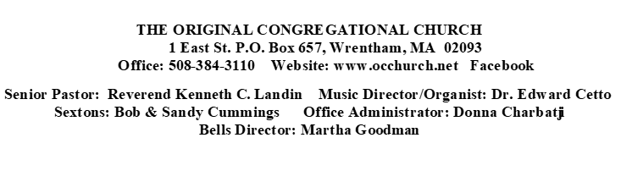

( 3 )

LIFE OF THE CHURCH
IN OUR PRAYERS…
Lynnete Beaudro, for prayers of safety during her deployment.
Muriel Beresford, for prayers of strength and health.
Cheryl Rowe, for prayers of continued recovery.
Dick Shirley, for prayers of a continued strong recouperation.
Steve Davis, for prayers of continued strength and resilience in healing.
Aida Catlow, for prayers of recouperation, healing and well-being.
Peg Mercier for prayers peace and healing.
The Maddy Harper Family, during the sudden loss of her brother in-law.

Today’s Flowers are Dedicated to the Glory of God

THANK YOU TO TODAY’S LITURGISTS:
THANK YOU TO TODAY’S COUNTERS: Jerry & Joyce Long, Mike Foster

There will be no Ushers in January or in February.

TODAY IS BLANKET SUNDAY FEBRUARY 27th.
Church World Service (CWS) envelopes are in the pews today for Blanket Sunday. This is an annual opportunity to support vulnerable people throughout the world during times of crisis or disaster. Donations are used to provide light and heavy weight blankets to victims as they endure storms, fires or warfare. This will be timely as the situation in the Ukraine continues to develop. All donations of any size are appreciated. Checks should be made out to the church with Blanket Sunday written in the memo. Thank you for considering this national and worldwide relief effort!

ASH WEDNESDAY SERVICE WILL BE HELD in the Sanctuary, Wednesday, March 2nd at 7:00pm to mark the beginning of the Lenten Season.
THE KITCHEN ELVES will resume Wednesday, March 2nd!! LADIES BREAKFAST will resume March 10th. Look for updates regarding Lunch Bunch, still on hold for now, in near future.

2022 Spring Yard Sale...The 2022 spring yard sale is scheduled to be held on May 21st, 2022, from 8 am to noon. Donations may be dropped off in the Vestry. Call Mike Foster if you need assistance. As usual, do not bring any clothes, books that aren’t in pristine condition, TVs, computers, large stereos, or large furniture.

( 4 )

OUTREACH

Local Afghan Relief Effort in Worcester

Keeping up with our state’s humanitarian response to the Afghan Refugee crisis, we have learned the organization WARM (Welcoming Alliance for Refugee Ministry) of Worcester (info@warmwelcoming.org ) is hard at work making a huge difference for locally relocated Afghan families. Partnering with Hope for Worcester and Living Word Church they have seized the opportunity to provide love and care through their work efforts.

On Saturday, February 5th, they prepared apartments for two Afghan families. Meeting together they cleaned, moved furniture and decorated the living spaces. On Wednesday the 9th, donations of food and clothing were collected at the Living Word Church, in hopes of meeting as many needs as possible of resettling refugees. We were able to quickly gather warm wear on short notice for Drop Off on the 9th. A big thank you for such a quick response!
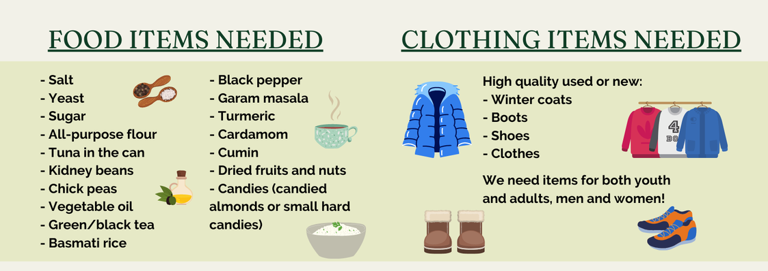
In order to prepare for another Drive Off date in the future, we would like to begin collections now. A box or two will be placed in the Fellowship Hall designating specific items needed for the cultural preferences of Afghan families. Please consider adding to this collection over the next weeks.

ZIMBABWE SUPPORT
Often, we can be frustrated that we don’t always see the effect of donations made to worthy causes. We are so fortunate that our support of the Daisy Dube Children’s Home in Zimbabwe is visible. This is possible because of our connection with Connie Littlefield and her amazing work in Zimbabwe. If you are interested in reading a summary of work accomplished, pick up a copy of her report on the table in the church library.

( 5 )

ONA UPDATE RE: OPEN FORUM III, TBA

At December’s Open Forum II, concern was expressed about how the OCC declaring itself an Open and Affirming church would affect its future. In response to that concern, the ONA Team is planning Open Forum III to be held when the current Covid spike has subsided and as many people as possible will be able to attend. With the understanding that no two churches are identical, we have invited Charlie Oliver of Second Congregational Church in Attleboro to share with us what his church experienced after it joined the ONA Coalition some years ago. Charlie was one of the leaders of their ONA Team and also has served as Moderator of his church. If time permits, after Charlie has spoken and answered questions, there will be an open discussion of ONA matters. Stay tuned (and safe) for a Save the Date!

Below is the “Covenant and Welcoming Statement” as presented by the Open and Affirming Task Team. We hope that this statement makes clear that the mission of ONA is to proclaim publicly an unqualified welcome to all people at the OCC. This statement expresses what is at the very heart and core of the ONA movement. Try reading it aloud to yourself – it is a very powerful statement! Any questions or comments? Please see Leesa Burke, Charlotte Capone, Jenn Chace, Jane Claffey, Ned Ligon, Joan Mello, or Walter Spencer.

Welcome to The Original Congregational Church in Wrentham! Because we believe all people are created in God’s image and thus blessed and loved equally by God, and because love is the unifying and strengthening force of our Christian faith, we the members of The Original Congregational Church, United Church of Christ, hereby declare ourselves an Open and Affirming Christian community, expressing Jesus’ inclusive embrace of all people.
We welcome all who have no church home, seek strength, and want to follow the teachings of Jesus.
We welcome believers and non-believers, doubters and questioners, and questioning believers.
We welcome new visitors and old friends.
We welcome grandparents, mothers, fathers and children.
We welcome single and partnered people.
We welcome people of all ages, colors, cultures, abilities, sexual orientations, gender identities and expressions.
Here at The Original Congregational Church, Wrentham, we believe that whoever you are, and wherever you are on life’s journey, you are welcome here.

Portions adapted from Bethany Church, Foxboro, MA, and United Church, Walpole, MA

( 6 )

